Sustainability
Annual Report 2025 – chapter 6
Noah Fischer · 27 February 2026
Sustainability is not a separate chapter of our business – it is our business. In 2025 our assets avoided 1.2 million tonnes of CO₂.
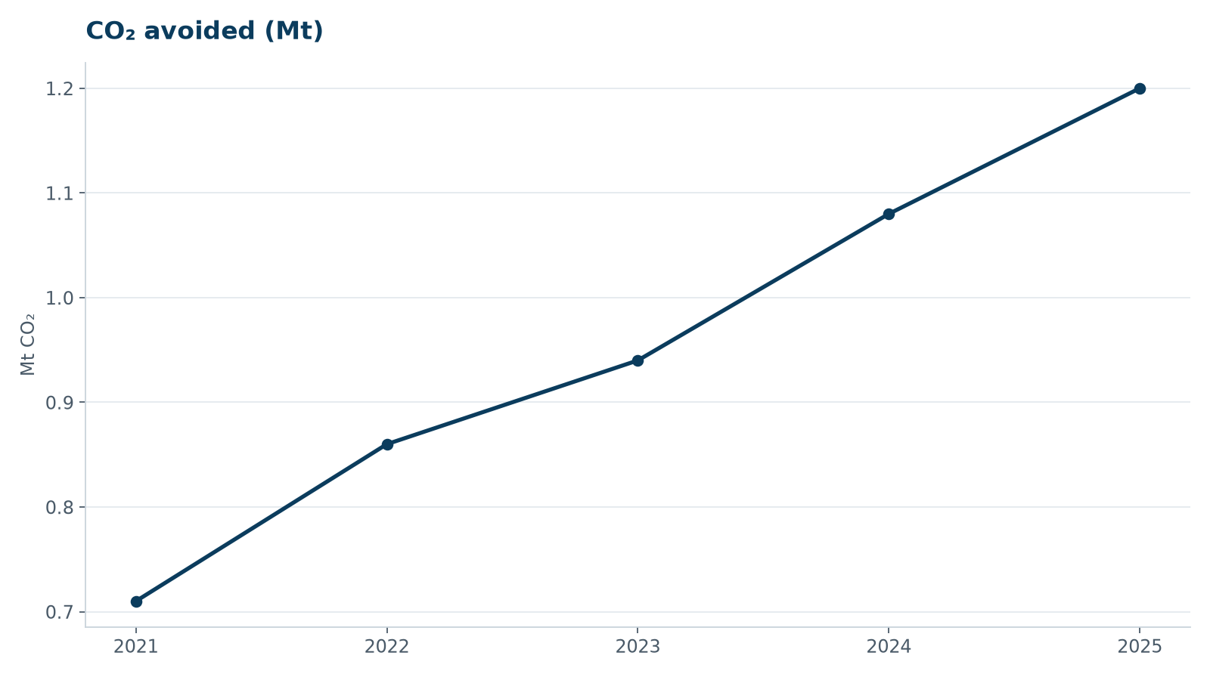
CO₂ avoided 2021–2025

Nature
Marlow Ecology carried out 46 seabird and marine mammal survey days for Harrow Bay in 2025. The results informed our piling noise mitigation plan with double bubble curtains and seasonal restrictions.
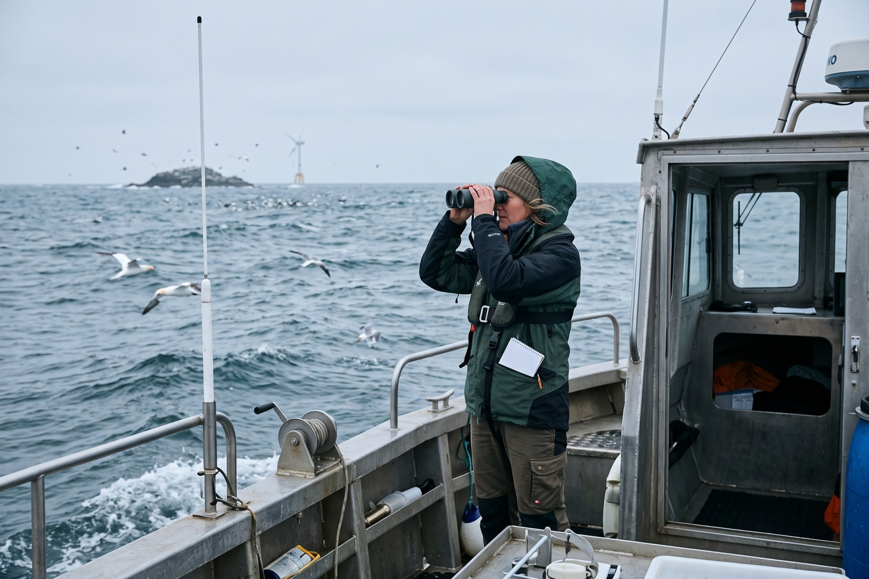
Seabird survey in the Harrow Bay area

People
We welcomed 52 new colleagues; the workforce grew to 450 employees from 31 nations. Women hold 31 % of leadership positions (2024: 27 %).
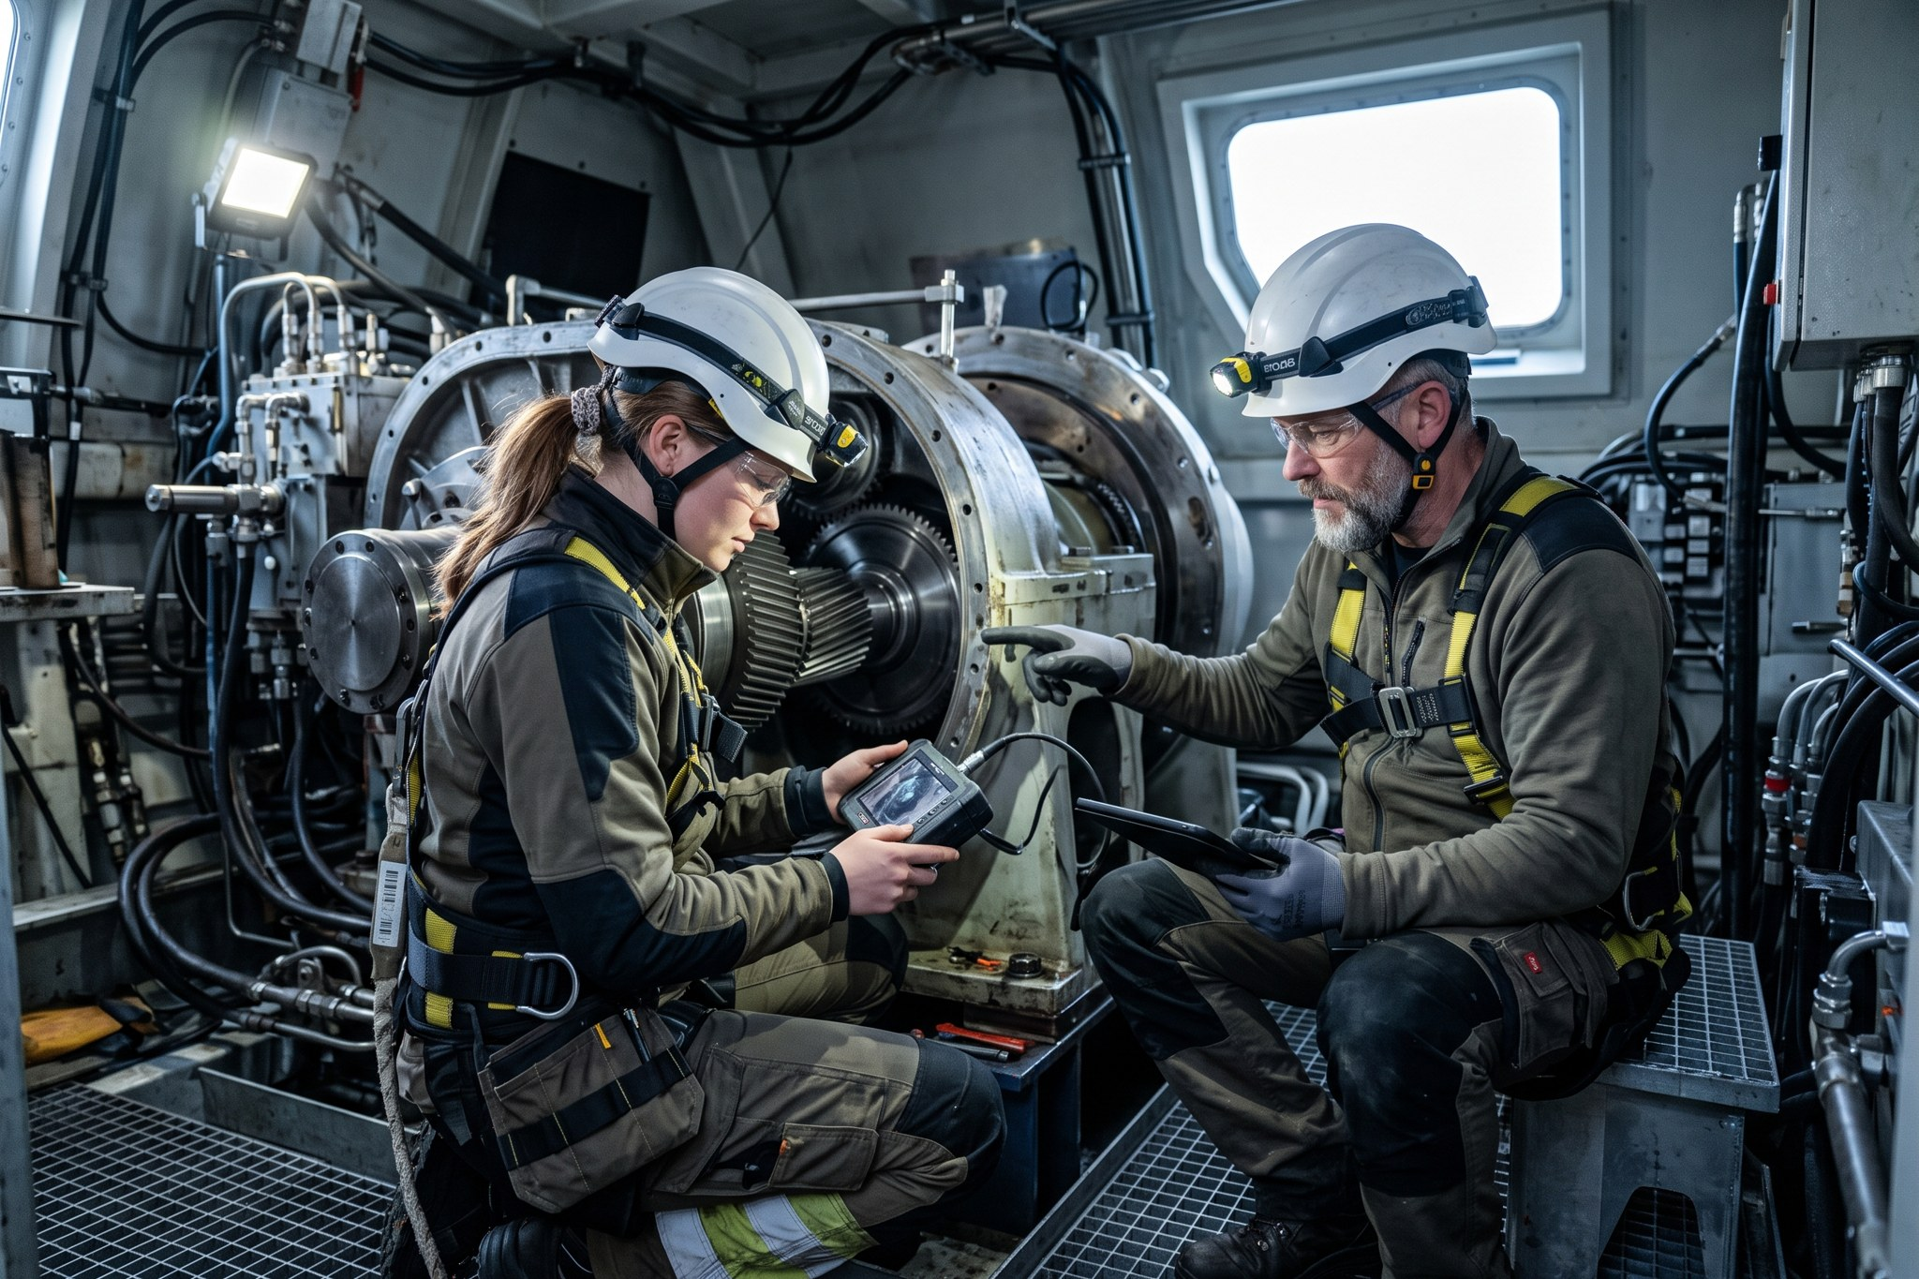
Technicians at Kestrel Ridge

Communities
Our community benefit funds paid EUR 745,000 to 63 local projects – from a new roof for the village hall near Kestrel Ridge to school science kits in Dithmarschen.

